Web Programming Activity 5 Static Analysis Tools

30003389 – Kyer Potts

# Static Analysis Tools for PHP code

Static analysis tools are used to identify errors according to code convention within a programmer written file. This allows users to all follow a specific set of coding conventions to create normalised code throughout working teams or cooperative efforts. Normalised code that follows specific conventions enhances readability and helps to promote coordination during collaborative coding projects.

To demonstrate this process I will be using Code Sniffer, which can be installed as a part of the XAMPP package. This install information is attached in the screenshot below.

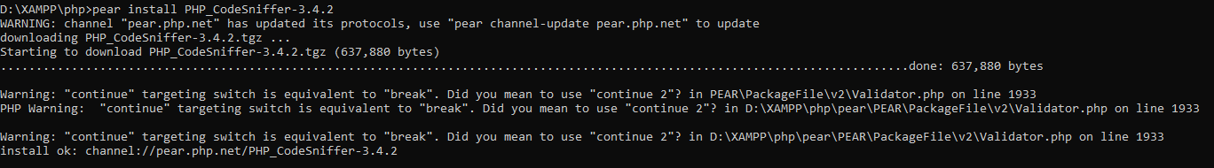

Once Code Sniffer has been installed, it can be run by entering the CodeSniffer command phpcs followed by the directory of the file you would like to parse for code convention errors. An error report will then be generated detailing the list of errors.

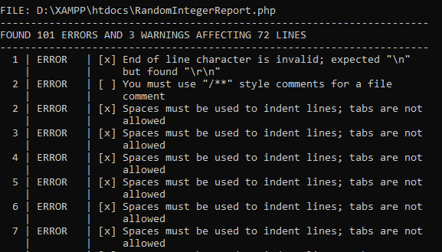

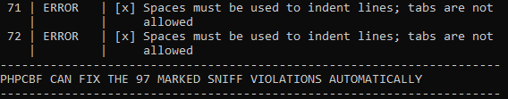

Once the report has been generated, the user can use the PHPCBF (Code BeautiFier) command to automatically correct all of the errors detected by the CodeSniffer tool.